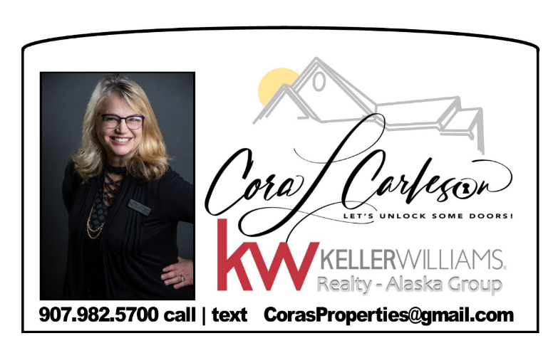

**Local Repair Companies:**

**Contractor**

Yakone Construction

**(907) 232-7472**

**Plumbing and Heating**

Northern Plumbing and Heating

[**(907) 952-0468**](tel:9077453211)

**Electrician**

Alaskan Electricians  
**(907) 302-9525**

**Junk Removal**

Valley Trash and Junk Removal

**(907) 414-7405**